**2025 WISCONSIN & MINNESOTA AQUACULTURE CONFERENCE**

***Exhibitor & Sponsorship Opportunities***

# The “Platinum” Package _____ $1000.00

* *Includes display table (if desired) and admittance for* ***two*** *individuals to breakfasts, lunches, and Friday Night gathering.*
* *Your business or association logo on all handouts, posters, announcements etc*

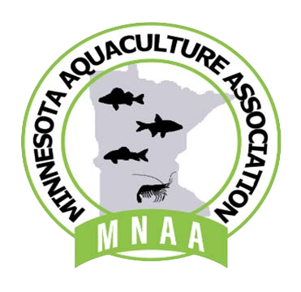

* *Introduction of business or association as Platinum Sponsor at the Friday Night Gathering.*
* *A 5-minute opportunity to introduce your business or association at the Friday Night Gathering*

# The “Gold” Package _____ $500.00

* *Includes display table (if desired) and admittance for* ***one*** *individual to breakfasts, lunches, and Friday Night Cookout as our guest.*
* *Your business or association logo on all handouts, posters, announcements etc*
* *Introduction of business or association as Gold Sponsor the Friday Night Gathering*

# The “Silver” Package _____ $350.00

* *Includes display table (if desired) and admittance for* ***one*** *individual to breakfasts, lunches, and Friday Night Gathering as our guest.*
* *Your business or association logo on all handouts, posters, announcements etc.*

# The “Bronze” Package _____ $250.00

* *Send us your catalogs and /or brochures for display on an unmanned, general tradeshow table. Note:*

*does not include a complimentary admittance.*

* *Your business or association logo on all handouts, posters, announcements etc.*

_________________________________________________________________________________________________

Company Name: ________________________________ Contact Person: ___________________________________

Address: ____________________________________ City: ______________________ Zip code: _______________ Phone: ____________________________ Email: ______________________________________________________

***Pay by February 8, 2025, to ensure inclusion in the 2025 Conference Attendee Packets.***

***Make a check payable to the Wisconsin Aquaculture Association and send form to:***

Wisconsin Aquaculture Association

Attn.: Staci Griffiths

1626 Stacy Ln,

Fort Atkinson, WI 53538

***Thank-you for supporting the 2025 Conference!***